EXPERIMENT 9
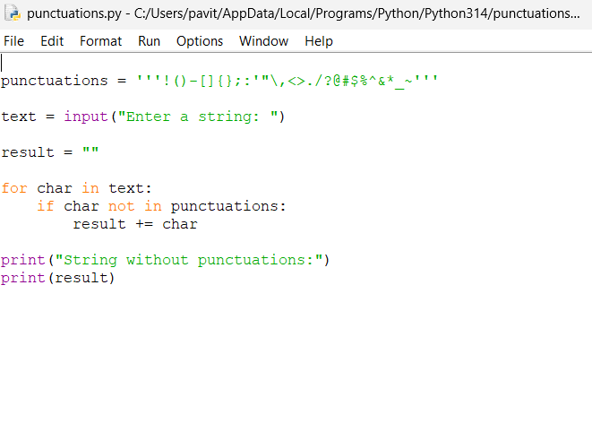
OUTPUT
